# 

# **Graded Assignment**

# **on**

# **Networking and Servers**

# 

# 

# 

# 

# 

# 

# 

# **Course 3:** Networking and Servers **| DevOps B4**

**Question 1:**

Deploy a website on localhost using either apache2 or Nginx. Create a DNS name for this website as ‘awesomeweb’. You can use any web template you want or can write your own simple HTML code. Write detailed documentation with the steps involved.

**Prerequisites:**

* A computer with a Linux operating system (e.g., Ubuntu).
* Basic understanding of terminal commands.

**Steps:**

**1.** Open your terminal and update package lists. If packages can be upgraded, then upgrade it.

**sudo apt update  
Sudo apt upgrade -y**

|  |
| --- |

**2.** Install Nginx:

**sudo apt install nginx**

|  |
| --- |

**3**. Create a Test Website:

Create a directory for your website files (e.g., /var/www/html/awesomeweb).

We'll use a simple HTML file for demonstration.

**sudo mkdir -p /var/www/html/awesomeweb**

**4.** Create an index.html file inside the directory with your preferred content.

HTML Code Block:

| <!DOCTYPE html>  <html>  <head>  <title>Awesome Website</title>  </head>  <body>  <h1>Welcome to my awesome website!</h1>  </body>  </html> |
| --- |

**Note**: You can replace this code with any HTML content you want for your website.

**5.** Configure Nginx Server Block:

Create a new server block configuration file:

**sudo nano /etc/nginx/sites-available/awesomeweb.conf**

**Nginx Server Block**

| server {  listen 80;  server_name localhost.awesomeweb.com;  location / {  root /var/www/html/awesomeweb;  index index.html index.htm;  }  error_log /var/log/nginx/awesomeweb_error.log;  access_log /var/log/nginx/awesomeweb_access.log;  } |
| --- |

Save and close the file.

**6.** Enable the Server Block:

Create a symbolic link from the available configuration file to the enabled sites directory:

**sudo ln -s /etc/nginx/sites-available/awesomeweb.conf /etc/nginx/sites-enabled/**

**7.** Test Nginx Configuration:

Check the Nginx configuration for syntax errors:

**sudo nginx -t**

If there are no errors, proceed to the next step. Otherwise, fix the errors in your configuration file and re-run the test command.

**8.** Restart Nginx:

**sudo systemctl restart nginx**

**9.** Configure Local DNS (hosts file):

Open the hosts file for editing:

**sudo nano /etc/hosts**

Add a new line at the bottom with the following format:

**127.0.0.1 localhost.awesomeweb.com**

**Note:** Replace awesomeweb with your desired DNS name for the website.

Save and close the file.

**10.** **Testing Your Website:**

Open a web browser and navigate to **http://localhost.awesomeweb.com/** (or your chosen DNS name) in the address bar. 

You should see your website content below if everything is set up correctly.

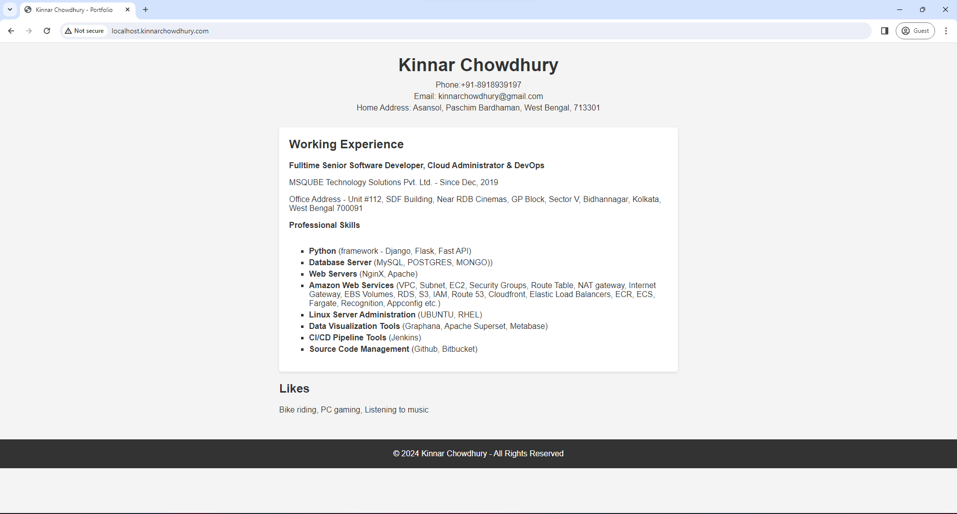

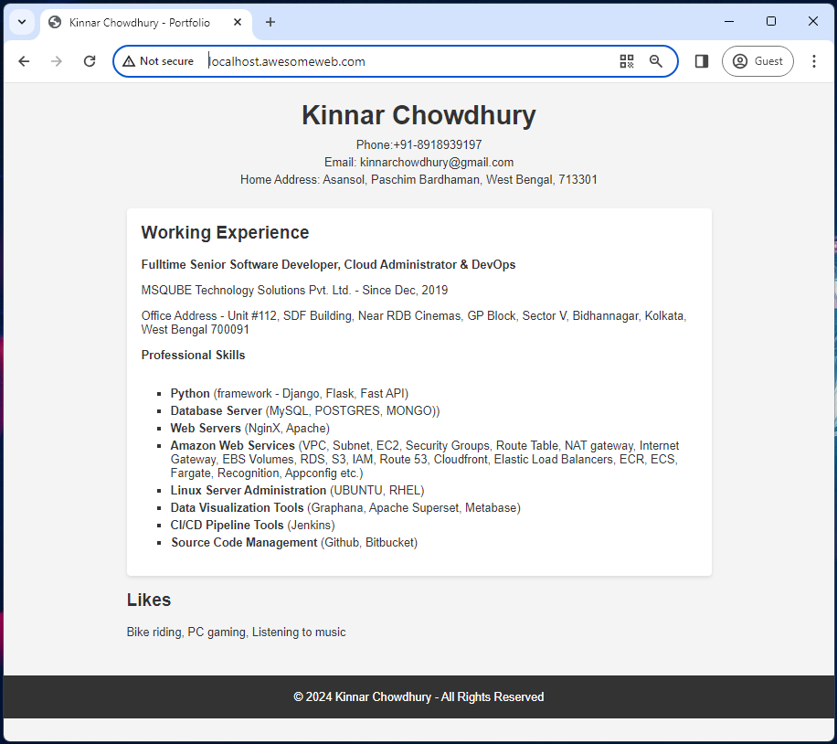  


THANK YOU

============================ **End of File** ============================